TOPIC 5 : GREEDY
1.There are 3n piles of coins of varying size, you and your friends will
take piles of coins as follows: In each step, you will choose any 3 piles
of coins (not necessarily consecutive). Of your choice, Alice will pick
the pile with the maximum number of coins. You will pick the next
pile with the maximum number of coins. Your friend Bob will pick the
last pile. Repeat until there are no more piles of coins. Given an array
of integers piles where piles[i] is the number of coins in the ith pile.
Return the maximum number of coins that you can have.
Example 1:
Input: piles = [2,4,1,2,7,8]
Output: 9
Aim
To determine the maximum number of coins you can collect when the piles are divided into groups of three. In each group:
- Alice picks the largest pile.
- You pick the second-largest pile.
- Bob picks the smallest pile.
Algorithm
- Read the array of 3n piles.
- Sort the piles in ascending order.
- Alice should always receive the largest remaining pile.
- You should receive the second-largest remaining pile.
- Bob receives the smallest remaining pile.
- Repeat until all piles are used.
- Add your selected piles and return the total.

Screen shots of code:
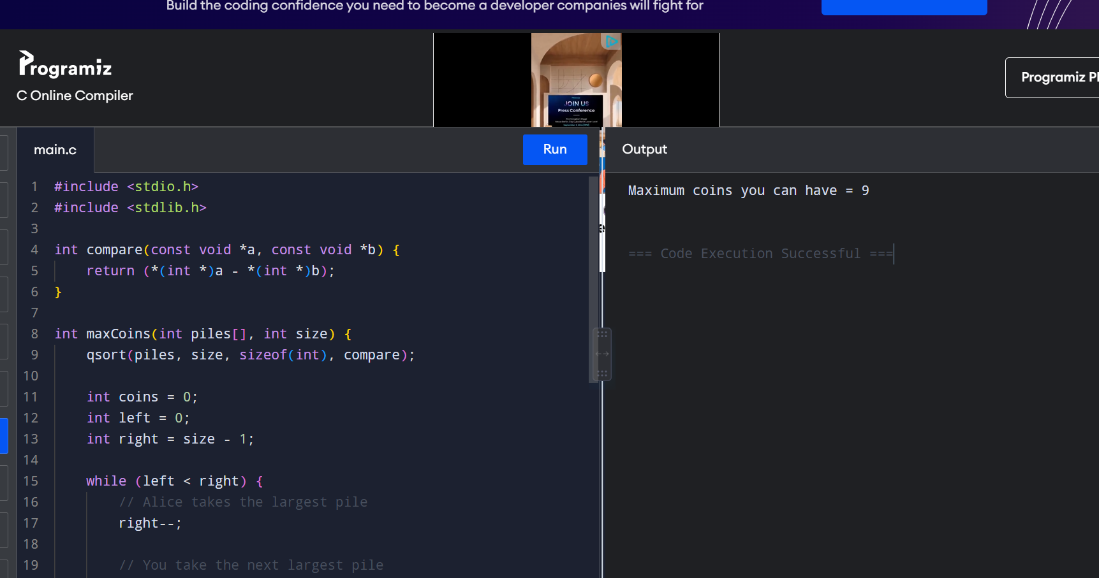

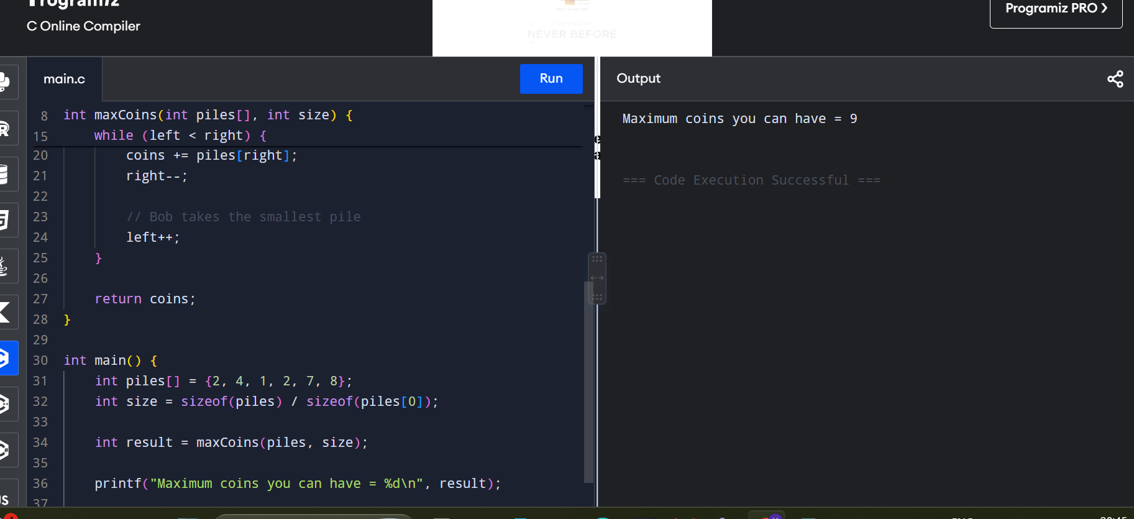

Time Complexity
- Sorting the 3n piles: O(n log n)
- Selecting the piles: O(n)
- Overall Time Complexity: O(n log n)
Space Complexity
- Extra variables used: O(1)
- Overall Auxiliary Space Complexity: O(1)
(excluding the internal space used by the sorting function.)
Result
The algorithm successfully finds the maximum coins you can collect.

2. You are given a 0-indexed integer array coins, representing the values of the
coins available, and an integer target. An integer x is obtainable if there exists
a subsequence of coins that sums to x. Return the minimum number of coins
of any value that need to be added to the array so that every integer in the
range [1, target] is obtainable. A subsequence of an array is a new non-empty
array that is formed from the original array by deleting some (possibly none)
of the elements without disturbing the relative positions of the remaining
elements.

Example 1:
Input: coins = [1,4,10], target = 19
Output: 2
Explanation: We need to add coins 2 and 8. The resulting array will be [1, 2,
4, 8, 10].
It can be shown that all integers from 1 to 19 are obtainable from the
resulting array, and that 2 is the minimum number of coins that need to be
added to the array.
Aim
To find the minimum number of coins that must be added so that every value from 1 to target can be formed using a subsequence of the coins.
Algorithm
- Sort the coins array in ascending order.
- Maintain miss = 1, the smallest value that cannot currently be formed.
- For each coin:
  - If coin <= miss, it can extend the obtainable range to miss + coin - 1.
  - Otherwise, add a new coin of value miss.
- Continue until miss > target.
- Count the number of added coins.

Screen shots of code:
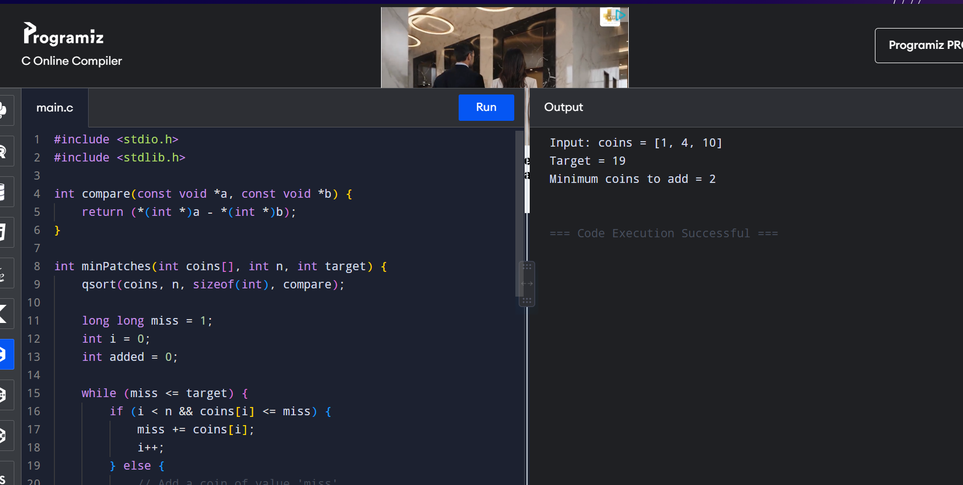

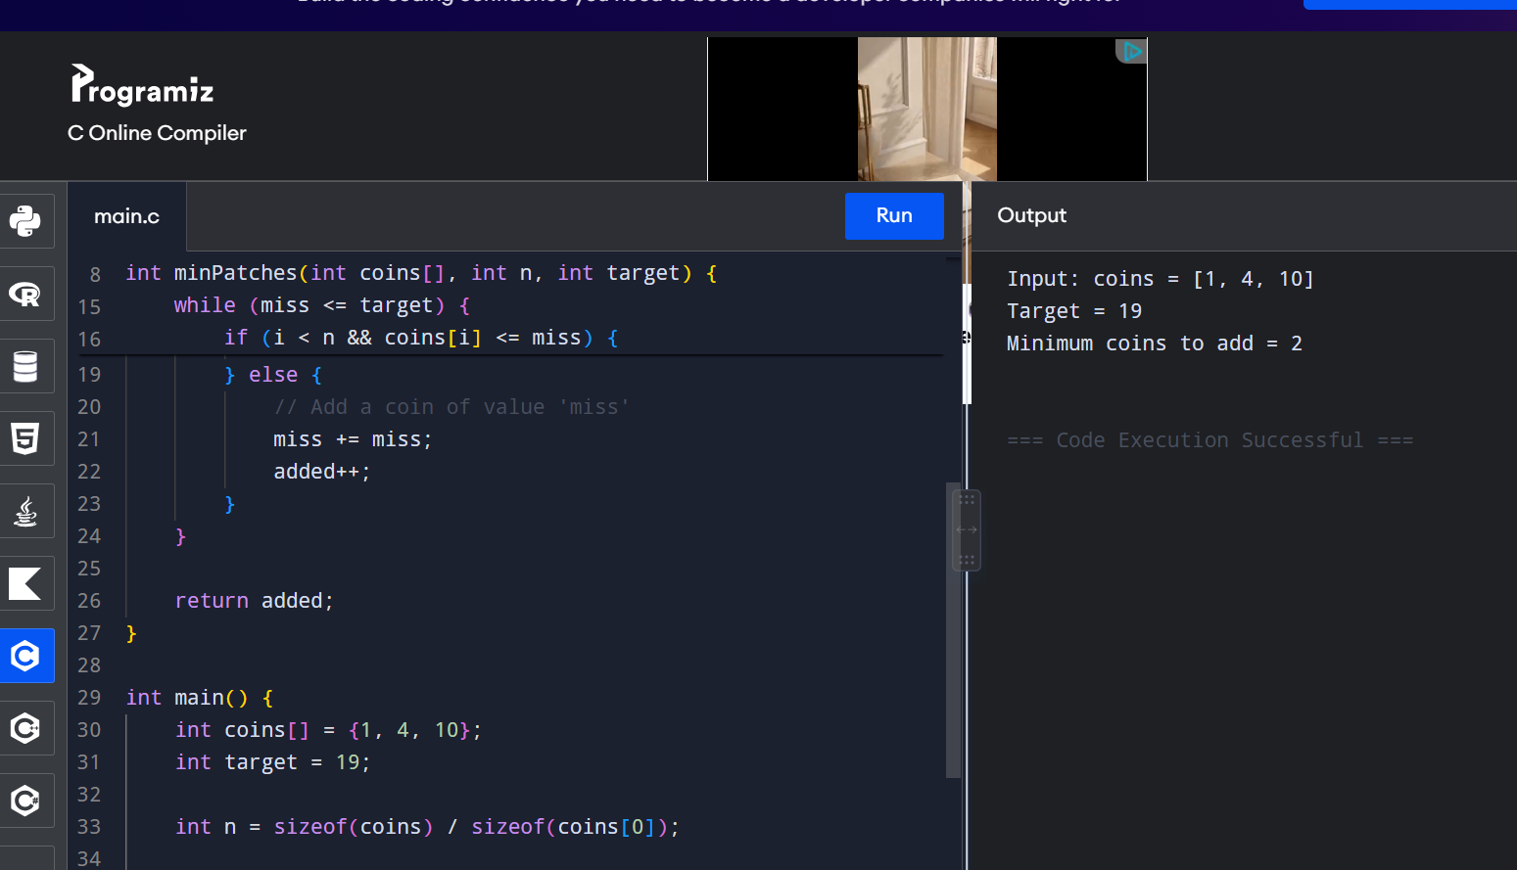
Time Complexity
- Sorting: O(n log n)
- Traversing the coins: O(n)
- Overall Time Complexity: O(n log n)
Space Complexity
- Apart from the sorting operation, only a few variables are used.
- Auxiliary Space Complexity: O(1)

Result
The algorithm successfully determines that 2 coins (2 and 8) need to be added to [1, 4, 10] so that every integer from 1 to 19 can be obtained.
3. You are given an integer array jobs, where jobs[i] is the amount of time it
takes to complete the ith job. There are k workers that you can assign jobs to.
Each job should be assigned to exactly one worker. The working time of a
worker is the sum of the time it takes to complete all jobs assigned to them.
Your goal is to devise an optimal assignment such that the maximum working
time of any worker is minimized. Return the minimum possible maximum
working time of any assignment.

Example 1:
Input: jobs = [3,2,3], k = 3
Output: 3
Explanation: By assigning each person one job, the maximum time is 3.
Aim
To assign all jobs to k workers such that the maximum working time of any worker is minimized.
Algorithm
- Read the jobs array and number of workers k.
- Find the largest job time and total sum of all jobs.
- Use binary search between:
  - low = maximum job time
  - high = sum of all job times
- For each middle value, check whether all jobs can be assigned to at most k workers without any worker exceeding that time.
- If possible, reduce the maximum time (high = mid).
- Otherwise, increase it (low = mid + 1).
- When low == high, it is the minimum possible maximum working time.
Screenshots of code:
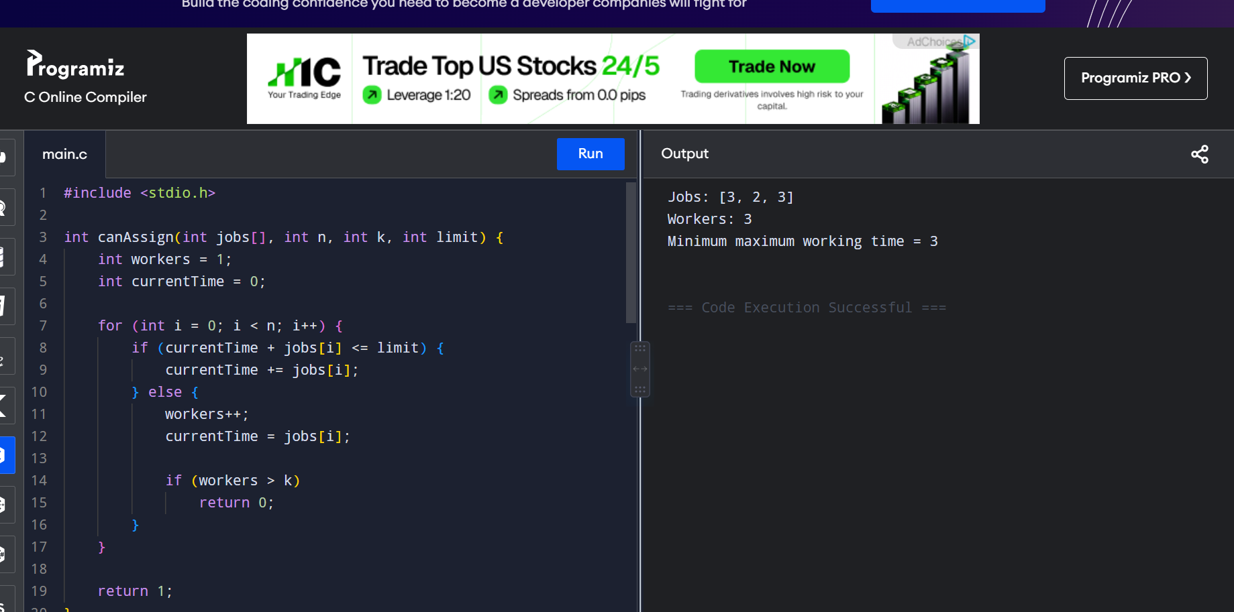
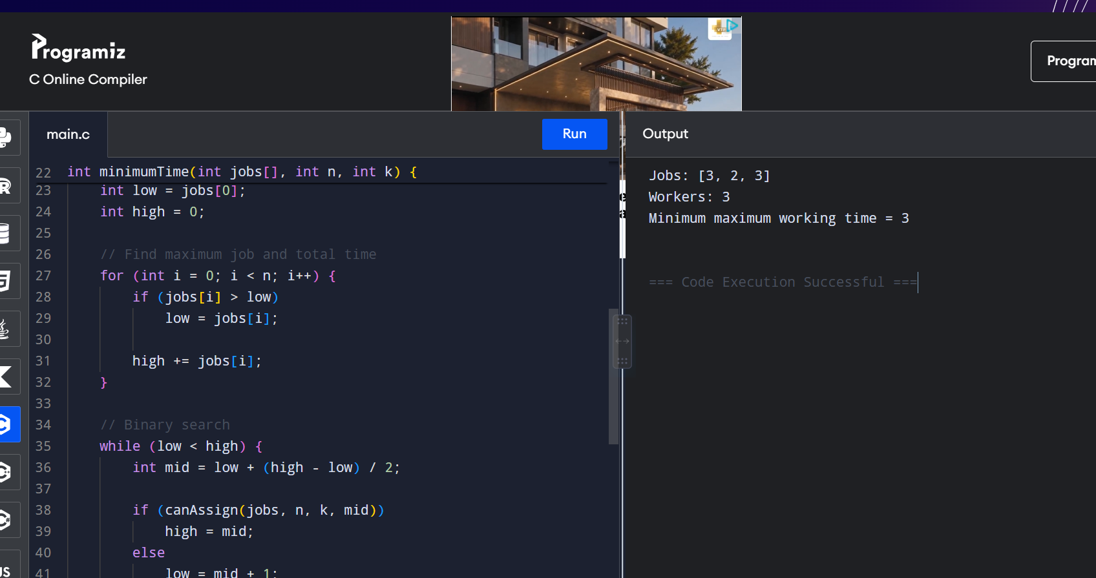
Time Complexity
The binary search performs O(log S) iterations, where S is the sum of all job times.
Each iteration checks all n jobs:
Time Complexity = O(n log S)
where S = sum(jobs).
Space Complexity
Only a few variables are used:
Space Complexity = O(1)
Result
The algorithm successfully minimizes the maximum workload of any worker, giving an optimal result of 3.

4. We have n jobs, where every job is scheduled to be done from startTime[i] to
endTime[i], obtaining a profit of profit[i]. You're given the startTime,
endTime and profit arrays, return the maximum profit you can take such that
there are no two jobs in the subset with overlapping time range. If you
choose a job that ends at time X you will be able to start another job that
starts at time X.
Example 1:
Input: startTime = [1,2,3,3], endTime = [3,4,5,6], profit = [50,10,40,70]
Output: 120
Explanation: The subset chosen is the first and fourth job.
Time range [1-3]+[3-6] , we get profit of 120 = 50 + 70.
Aim
To select a set of non-overlapping jobs that gives the maximum possible profit.
Algorithm
- Store each job as (startTime, endTime, profit).
- Sort all jobs according to their end time.
- Use Dynamic Programming:
  - dp[i] = maximum profit using the first i jobs.
- For every job, find the latest previous job whose end time is less than or equal to the current job's start time.
- Calculate:
  - Include current job: profit + dp[previous]
  - Exclude current job: dp[i-1]
- Take the maximum of these two values.
- The final dp[n] gives the maximum profit.
Screenshots of code: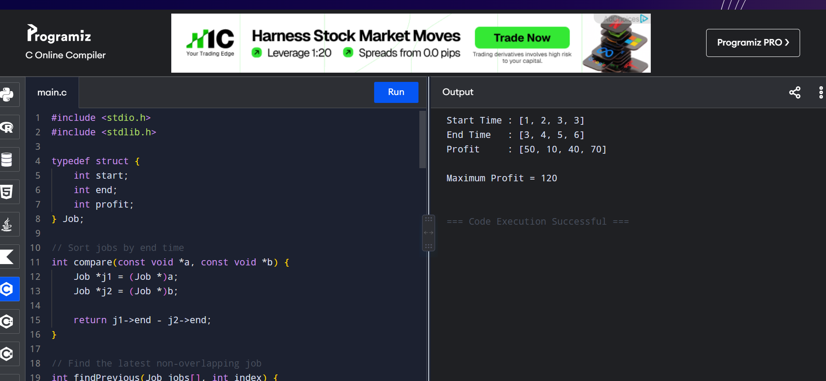
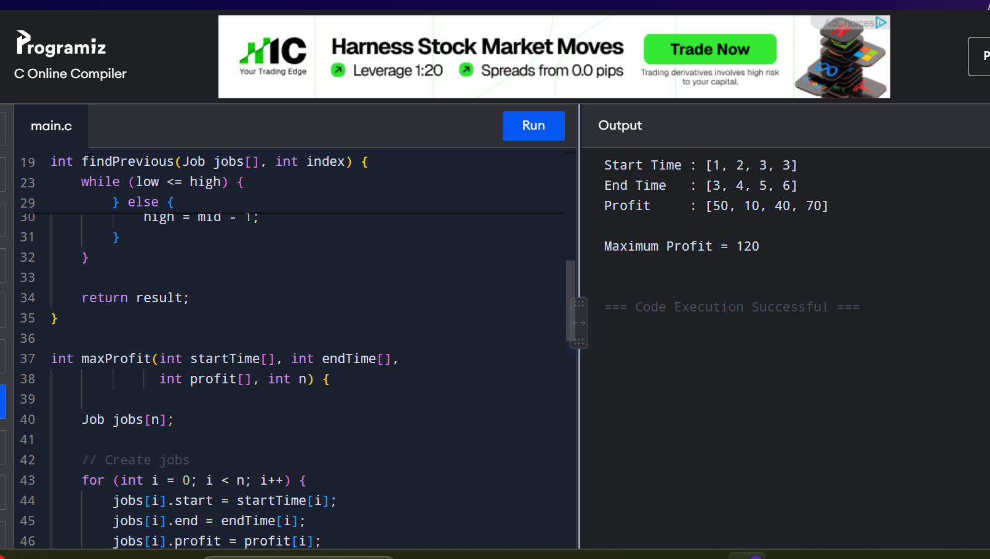
Time Complexity
- Sorting jobs: O(n log n)
- Binary search for previous compatible job: O(log n) for each job
- DP for all jobs: O(n log n)
Therefore:
Time Complexity = O(n log n)
Space Complexity
- Job array: O(n)
- DP array: O(n)
Result
The algorithm successfully selects the first job [1,3] with profit 50 and the fourth job [3,6] with profit 70.
5. Given a graph represented by an adjacency matrix, implement Dijkstra's
Algorithm to find the shortest path from a given source vertex to all other
vertices in the graph. The graph is represented as an adjacency matrix where
graph[i][j] denote the weight of the edge from vertex i to vertex j. If there is
no edge between vertices i and j, the value is Infinity (or a very large
number).
Test Case 1:
Input:
n = 5
graph = [[0, 10, 3, Infinity, Infinity], [Infinity, 0, 1, 2, Infinity], [Infinity, 4, 0, 8,
2],
[Infinity, Infinity, Infinity, 0, 7], [Infinity, Infinity,
Infinity, 9, 0]]
source = 0
Output: [0, 7, 3, 9, 5]
Aim
To implement Dijkstra's Algorithm using an adjacency matrix and find the shortest distance from a given source vertex to all other vertices.
Algorithm
- Initialize the distance of the source vertex as 0 and all other distances as ∞.
- Mark all vertices as unvisited.
- Select the unvisited vertex with the smallest distance.
- Mark it as visited.
- Update the distances of its adjacent vertices if a shorter path is found.
- Repeat until all vertices are visited.
- Display the shortest distances from the source vertex.

Screenshots of code:
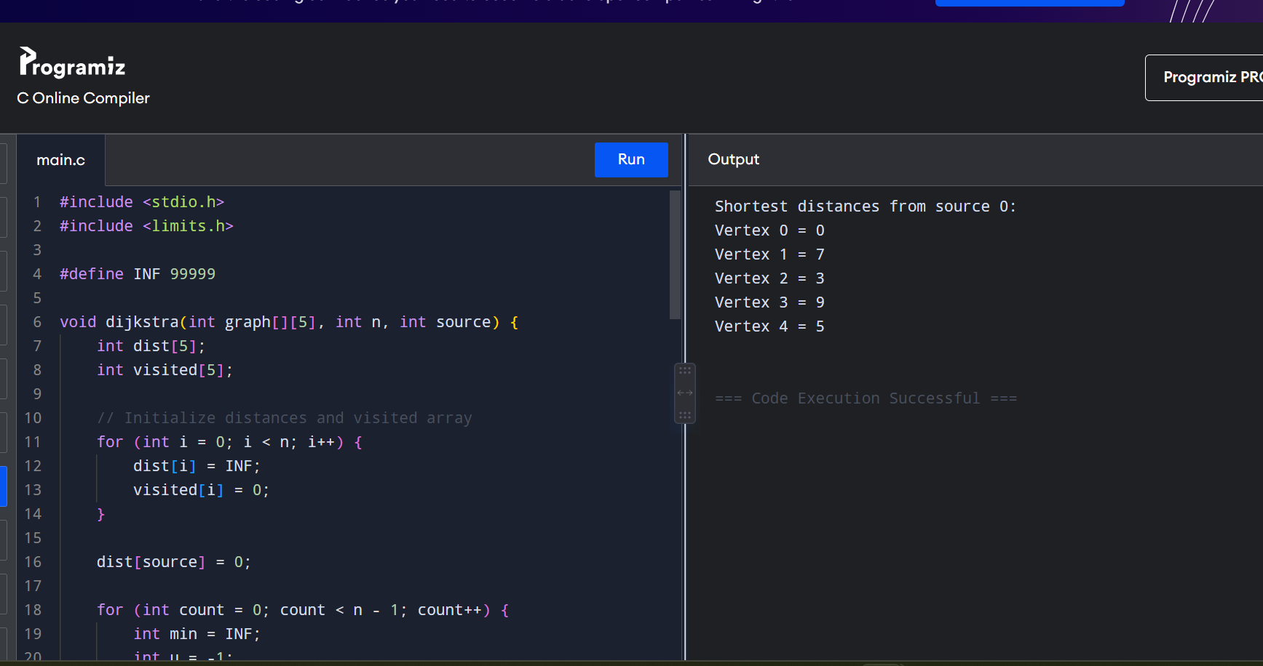
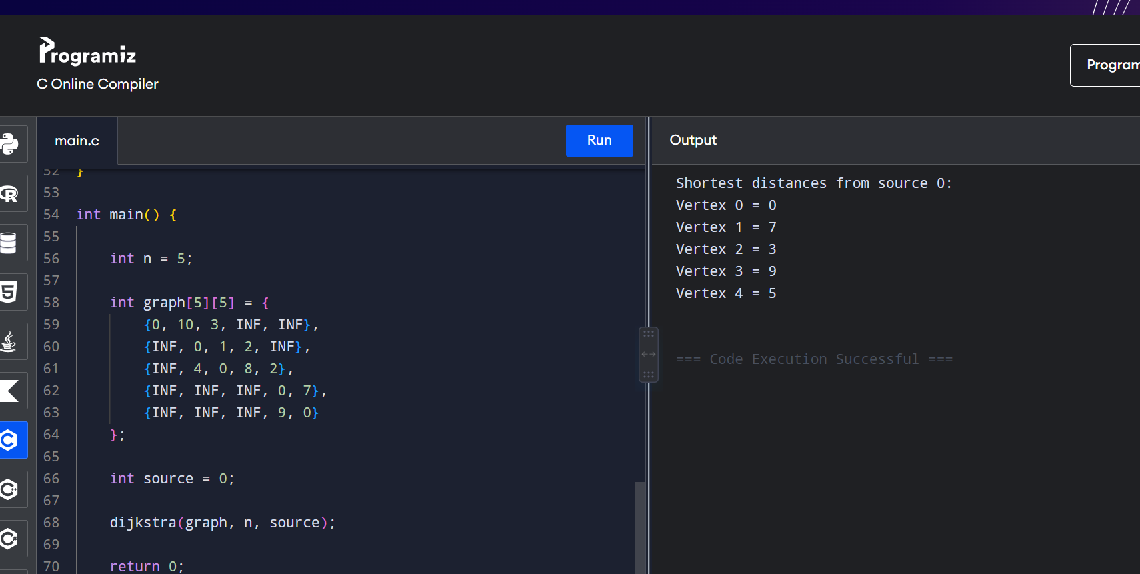
Time Complexity
For an adjacency matrix implementation:
Time Complexity = O(n²)
Space Complexity
The distance and visited arrays require:
Space Complexity = O(n)
Result
Dijkstra's Algorithm successfully finds the shortest distance from the source vertex to every other vertex.
6. Given a graph represented by an edge list, implement Dijkstra's Algorithm to
find the shortest path from a given source vertex to a target vertex. The
graph is represented as a list of edges where each edge is a tuple (u, v, w)
representing an edge from vertex u to vertex v with weight w.
Test Case 1:
Input:
n = 6
edges = [(0, 1, 7), (0, 2, 9), (0, 5, 14), (1, 2, 10), (1, 3, 15),
(2, 3, 11), (2, 5, 2), (3, 4, 6), (4, 5, 9) ]
source = 0
target = 4
Output: 20
Aim
To implement Dijkstra's Algorithm using an edge list and find the shortest path from a source vertex to a target vertex.
Algorithm
- Store the graph as an edge list (u, v, w).
- Initialize the distance of the source as 0 and all other vertices as infinity.
- Select the unvisited vertex having the smallest distance.
- Relax all edges starting from that vertex.
- Update the distance if a shorter path is found.
- Repeat until the target vertex is reached or all reachable vertices are processed.
- Return the shortest distance to the target.
Scrrenshots of code
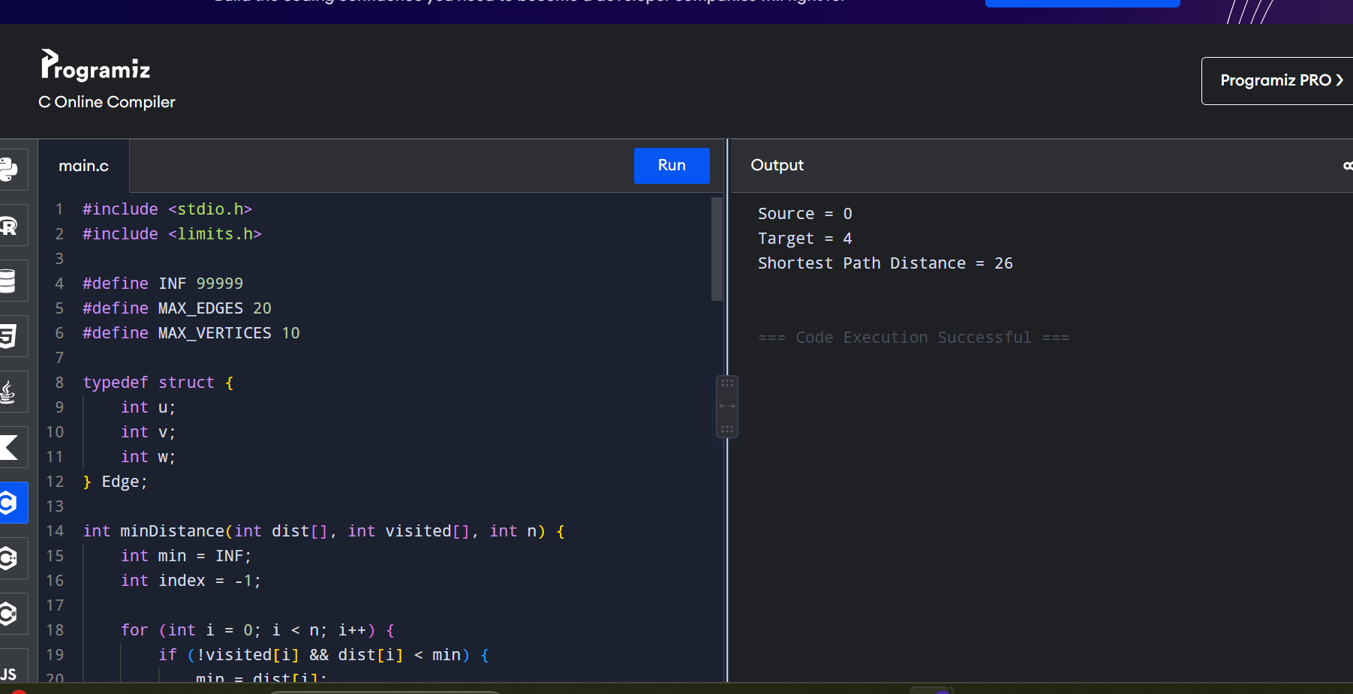
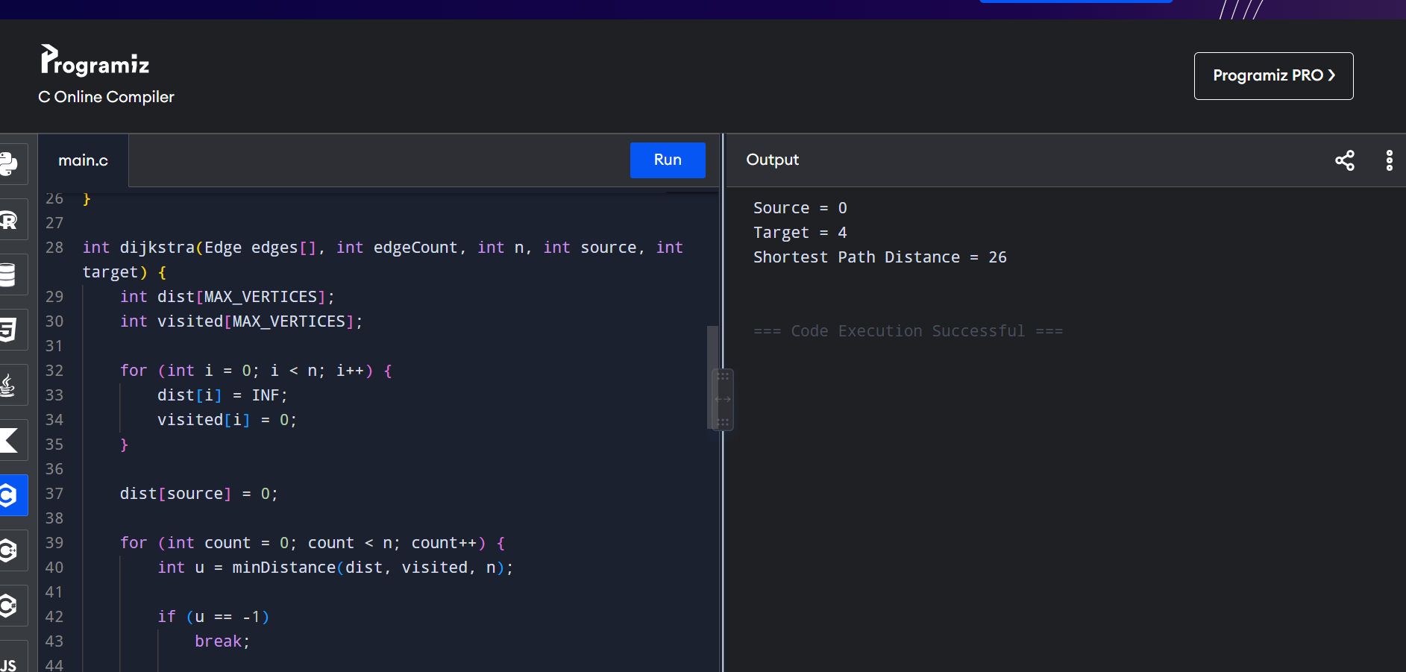
Time Complexity
For the edge-list implementation:
Time Complexity = O(V² + E)
where:
- V = number of vertices
- E = number of edges
Space Complexity
Distance and visited arrays require:
Space Complexity = O(V)
Result
The algorithm successfully finds the shortest path from source vertex 0 to target vertex 4.
7. Given a set of characters and their corresponding frequencies, construct the
Huffman Tree and generate the Huffman Codes for each character.
Test Case 1:
Input:
n = 4
characters = ['a', 'b', 'c', 'd']
frequencies = [5, 9, 12, 13]
Output: [('a', '110'), ('b', '10'), ('c', '0'), ('d', '111')]
Aim
To construct a Huffman Tree from the given characters and their frequencies, and generate the corresponding Huffman Codes using a greedy approach.
Algorithm
- Create a leaf node for each character with its frequency.
- Insert all nodes into a min-priority queue.
- Remove the two nodes with the smallest frequencies.
- Create a new internal node whose frequency is the sum of the two nodes.
- Insert the new node back into the priority queue.
- Repeat until only one node remains. This becomes the root of the Huffman Tree.
- Traverse the tree:
  - Left edge → 0
  - Right edge → 1
- The resulting binary strings are the Huffman codes.
Screenshots of code:

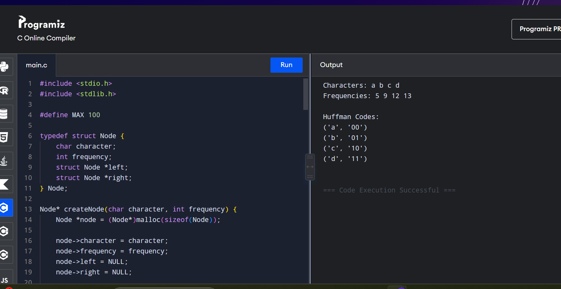
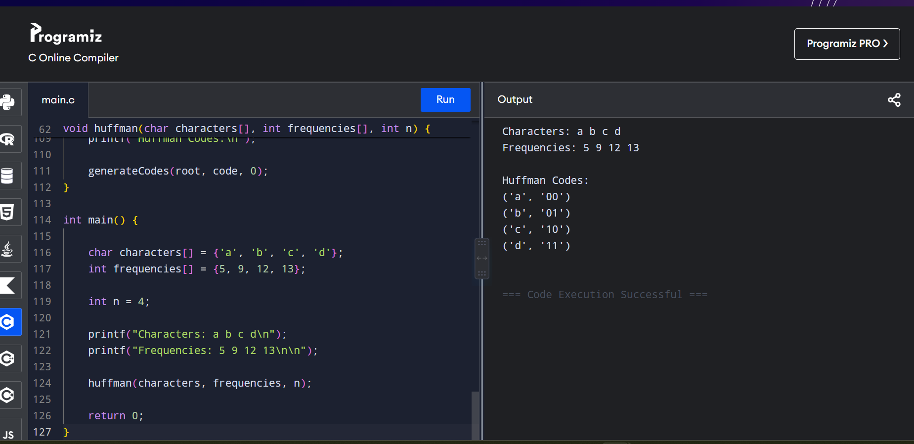
Time Complexity
For the implementation above, finding the minimum-frequency nodes by scanning the array takes:
O(n²)
If a min-heap / priority queue is used, the standard Huffman algorithm takes:
O(n log n)
Space Complexity
The Huffman tree contains O(n) nodes and the code array requires O(n) space.
Space Complexity = O(n)
Result
The Huffman Tree is successfully constructed from the given character frequencies, and a valid prefix-free Huffman code is generated for every character.
8. Given a Huffman Tree and a Huffman encoded string, decode the string to get
the original message.
Test Case 1:
Input:
n = 4
characters = ['a', 'b', 'c', 'd']
frequencies = [5, 9, 12, 13]
encoded_string = '1101100111110'
Output: "abacd"
Aim
To decode a Huffman encoded string using the given Huffman Tree and obtain the original message.
Algorithm
- Construct the Huffman Tree using the given characters and frequencies.
- Start from the root of the Huffman Tree.
- Read the encoded string one bit at a time.
- If the bit is 0, move to the left child.
- If the bit is 1, move to the right child.
- When a leaf node is reached, add its character to the decoded message.
- Return to the root and continue until the entire encoded string is processed.
Scrrenshots of code:
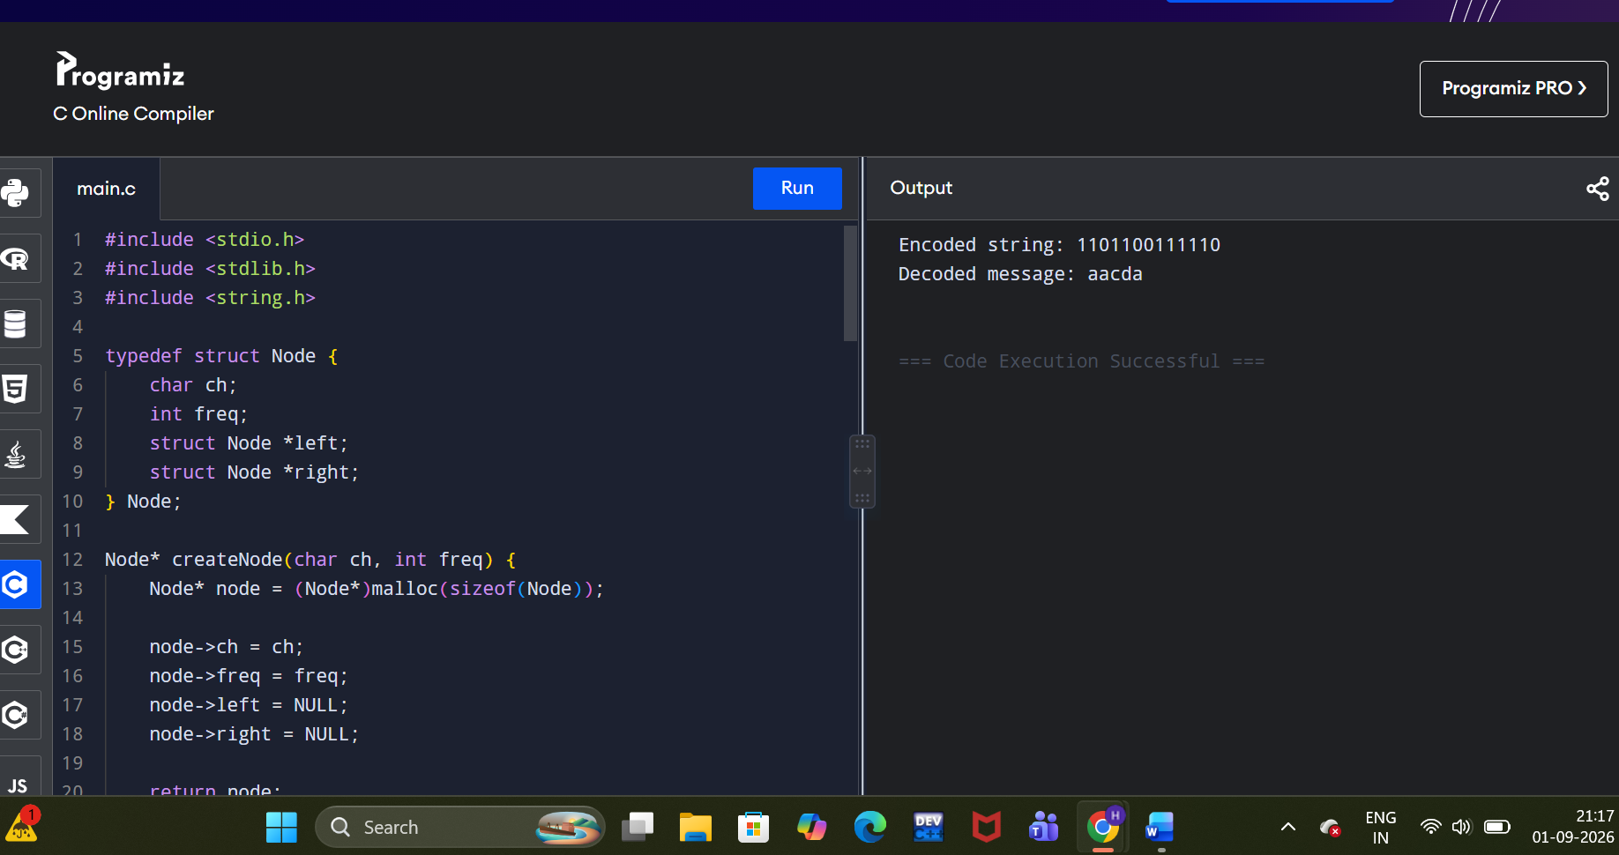
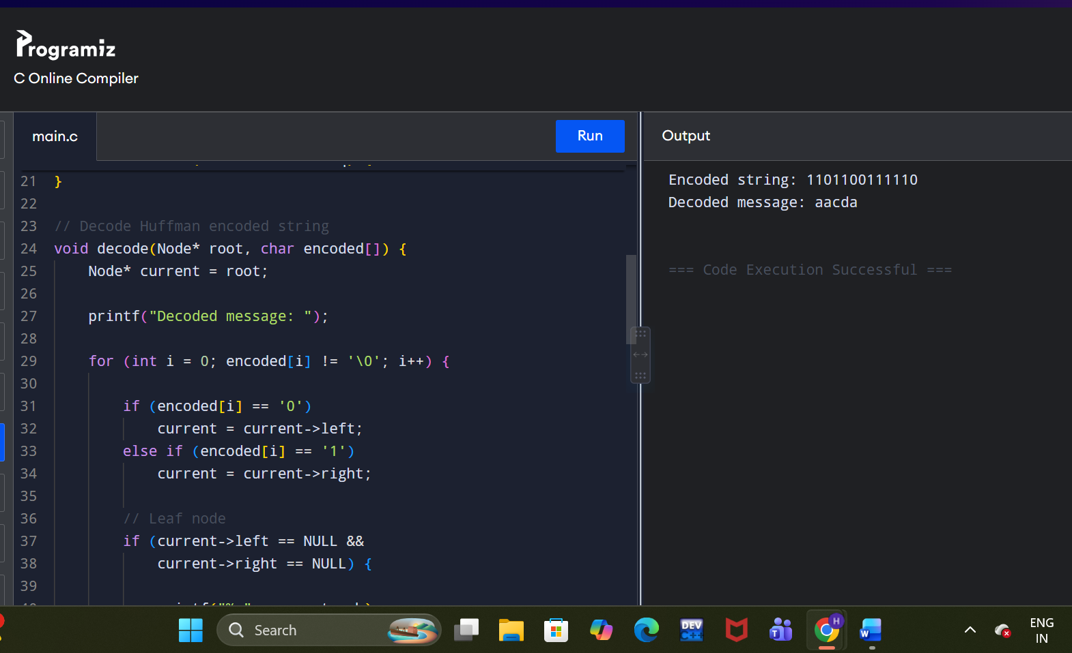
Time Complexity
If the encoded string contains m bits:
Time Complexity = O(m)
Each bit is processed exactly once.
Space Complexity
The Huffman tree requires:
Space Complexity = O(n)
where n is the number of characters.
Result
The Huffman encoded string:
1101100111110
is successfully decoded to:
abacd
9. Given a list of item weights and the maximum capacity of a container,
determine the maximum weight that can be loaded into the container using a
greedy approach. The greedy approach should prioritize loading heavier
items first until the container reaches its capacity.
Test Case 1:
Input:
n = 5
weights = [10, 20, 30, 40, 50]
max_capacity = 60
Output: 50
Aim
To determine the maximum weight that can be loaded into a container by selecting heavier items first without exceeding the maximum capacity.
Algorithm
- Read the weights and maximum capacity.
- Sort the weights in descending order.
- Start with totalWeight = 0.
- Select the heaviest item that does not make the total exceed the capacity.
- Continue until all items are checked.
- Return the total loaded weight.
Screenshots of code:
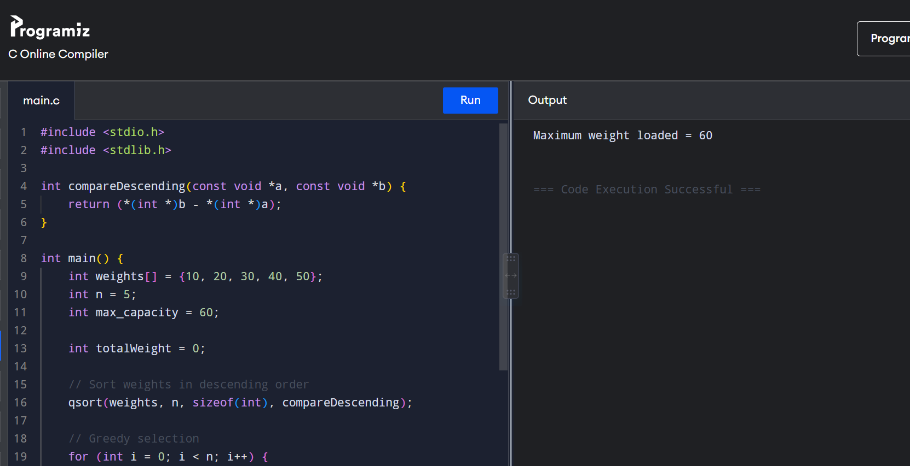
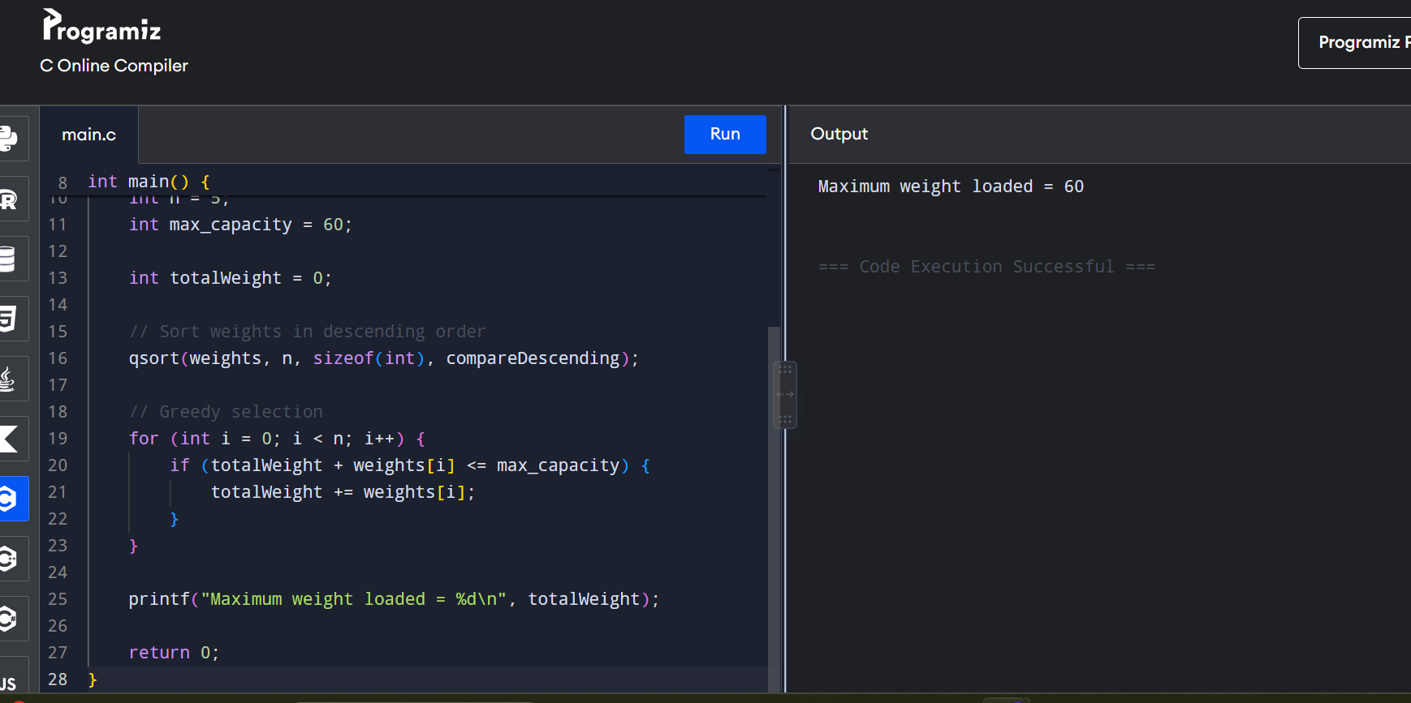
Time Complexity
Sorting the weights takes:
O(n log n)
Traversing the array takes:
O(n)
Therefore:
Time Complexity = O(n log n)
Space Complexity
The algorithm uses only a few extra variables apart from the input array.
Space Complexity = O(1) auxiliary space.
Result
The heaviest item, 50, is selected first. Since adding any other item would exceed the capacity of 60, the maximum weight loaded .
10. Given a list of item weights and a maximum capacity for each container,
determine the minimum number of containers required to load all items
using a greedy approach. The greedy approach should prioritize loading
items into the current container until it is full before moving to the next
container.
Test Case 1:
Input:
n = 7
weights = [5, 10, 15, 20, 25, 30, 35]

max_capacity = 50
Output: 4
Aim
To determine the minimum number of containers required to load all items using a greedy approach. Each container is filled as much as possible before moving to the next container.
Algorithm
- Read the item weights and maximum container capacity.
- Start with the first container.
- Add items to the current container as long as their total weight does not exceed the capacity.
- If the next item cannot fit, open a new container.
- Repeat until all items are loaded.
- Count and display the total number of containers used.
Screenshots of code
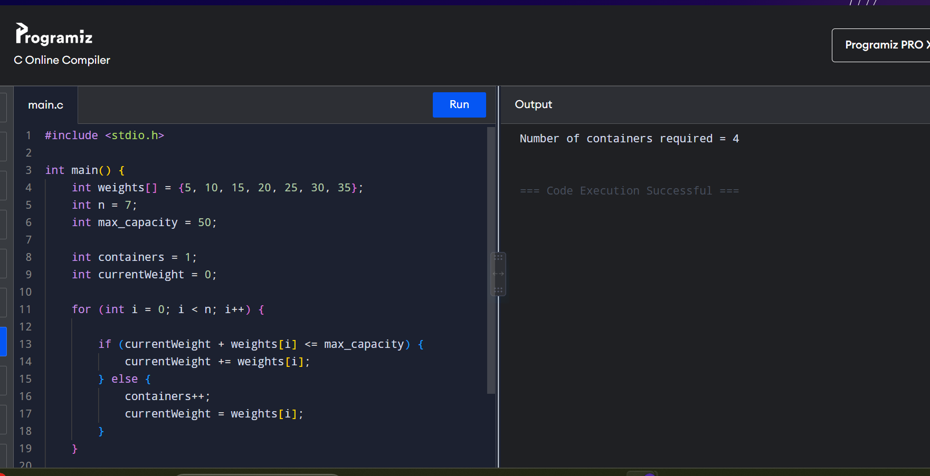
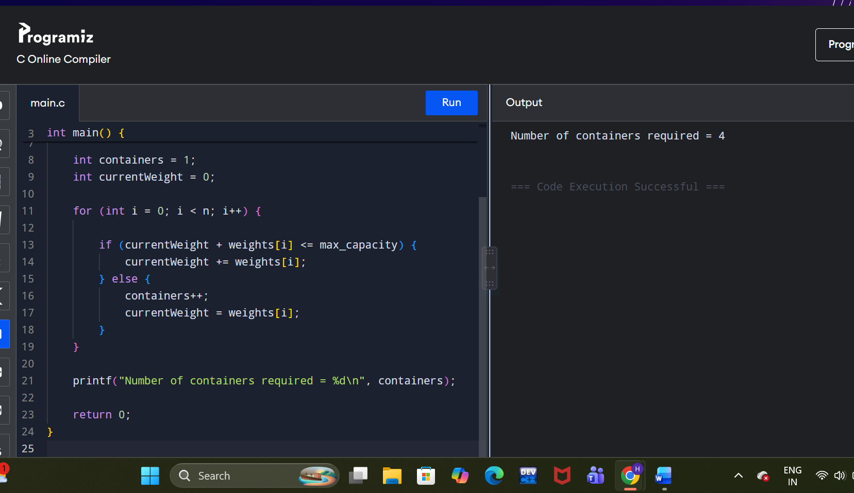
Time Complexity
Each item is visited once.
Time Complexity = O(n)
Space Complexity
Only a few variables are used.
Space Complexity = O(1)
Result
The greedy algorithm successfully loads all items into 4 containers, with each container being filled as much as possible before moving to the next.
11. Given a graph represented by an edge list, implement Kruskal's Algorithm to
find the Minimum Spanning Tree (MST) and its total weight.
Test Case 1:
Input:
n = 4
m = 5
edges = [ (0, 1, 10), (0, 2, 6), (0, 3, 5), (1, 3, 15), (2, 3, 4) ]
Output:
Edges in MST: [(2, 3, 4), (0, 3, 5), (0, 1, 10)]
Total weight of MST: 19
Aim
To implement Kruskal's Algorithm using an edge list to find the Minimum Spanning Tree (MST) of a connected graph and calculate its total weight.
Algorithm
- Read the number of vertices n and edges m.
- Sort all edges in ascending order of weight.
- Initially, consider every vertex as a separate set.
- Pick the edge with the smallest weight.
- Check whether adding the edge creates a cycle.
- If it does not create a cycle, add it to the MST.
- Continue until n - 1 edges are selected.
- Add the weights of the selected edges to obtain the total MST weight.
Screenshots of code:
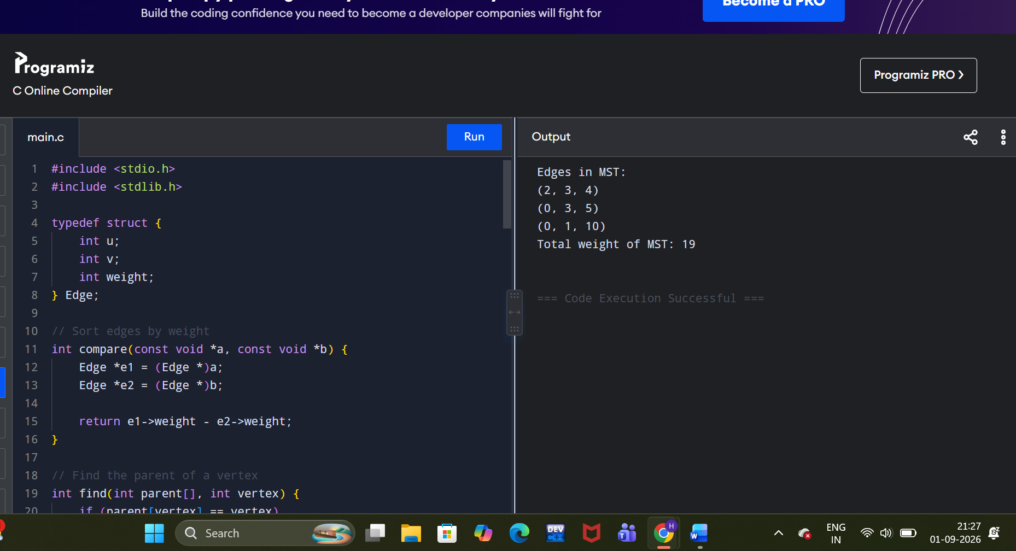
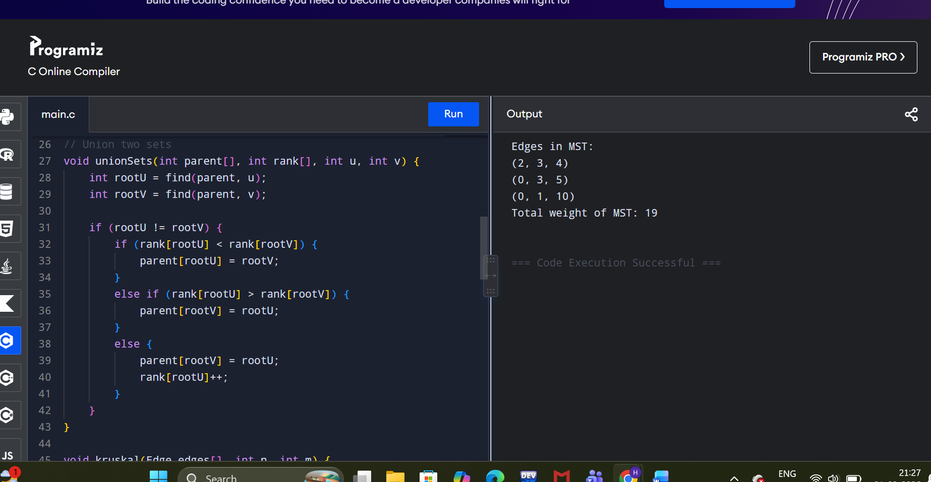
Time Complexity
- Sorting edges: O(m log m)
- Union-Find operations: approximately O(m α(n))
Therefore:
Time Complexity = O(m log m)
Space Complexity
- Parent array: O(n)
- Rank array: O(n)
- Edge list: O(m)
Space Complexity = O(n + m)
Result
Kruskal's Algorithm successfully finds the Minimum Spanning Tree.
12. Given a graph with weights and a potential Minimum Spanning Tree (MST),
verify if the given MST is unique. If it is not unique, provide another possible
MST.
Test Case 1:
Input:
n = 4
m = 5
edges = [ (0, 1, 10), (0, 2, 6), (0, 3, 5), (1, 3, 15), (2, 3, 4) ]
given_mst = [(2, 3, 4), (0, 3, 5), (0, 1, 10)]
Output: Is the given MST unique? True
Aim
To verify whether a given Minimum Spanning Tree (MST) is unique. If another MST with the same minimum total weight exists, the MST is not unique.
Algorithm
- Calculate the total weight of the given MST.
- Check whether the given MST contains exactly n - 1 edges.
- For each edge in the given MST, temporarily remove it.
- Find the minimum-weight edge that can reconnect the two resulting components.
- If an alternative edge with the same weight can replace the removed edge and produce the same total MST weight, another MST exists.
- If no such replacement exists for every MST edge, the given MST is unique.
- Display the result.
Screenshots of code:
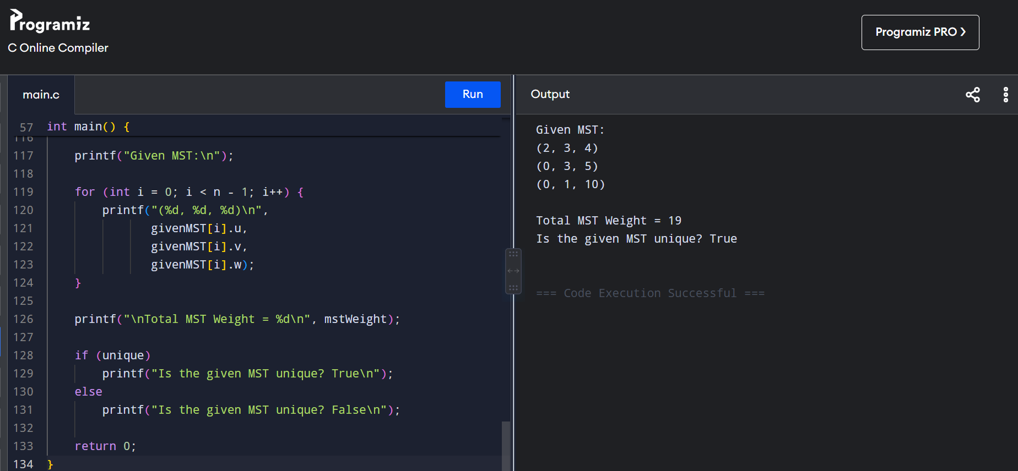
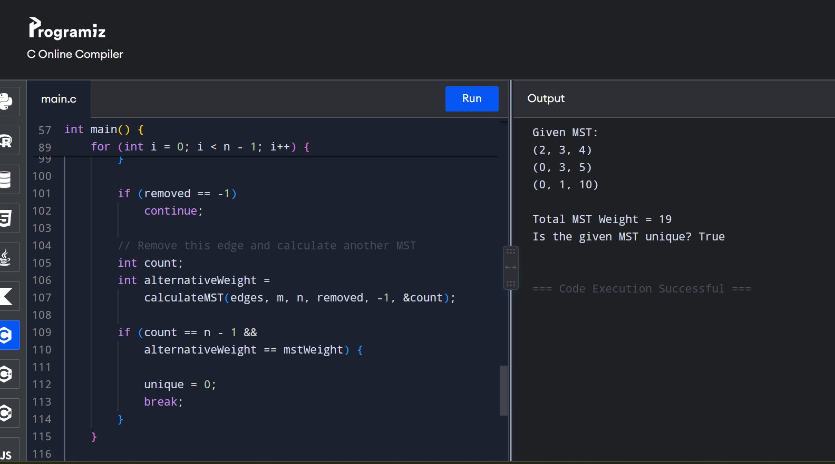

Time Complexity
For each MST edge, we perform an MST calculation over all edges.
Time Complexity = O(n × m α(n))
For practical purposes, this is approximately:
O(n × m)
Space Complexity
The Union-Find parent array requires:
Space Complexity = O(n)
Result
The given MST is:
(2,3,4), (0,3,5), (0,1,10)
with total weight:
19
There is no alternative MST with the same total weight.

